# Creating a PSAM Diagram

One use of the MRM is to easily visualize areas that deliver high-priority outcomes or opportunities to improve performance. With the SDW you can create a heatmap that shows how well the services are addressing target group needs. The **Program Service Alignment Model** (PSAM) is intended to depict the following model elements and relationships for a particular target group and set of needs:

* Organization Unit accountableFor Program administers Service (produces Output has Service Value) contributesTo Outcome
* Service assessedBy Performance Indicator

Once these elements are displayed on a diagram you can use a heat map to for example indicate whether the Actual Performance is equal to the Performance Target

Currently, the Performance Indicator algorithms, values and related objectives (the target values) in the MRM are all human-interpreted text. So there's no automated way to evaluate them. This needs to be addressed with some more specific criteria with definitive values so that performance assessments can be visualized better. This needs to be discussed with Skip and Roy. One possibility is to include an assessment property in MRM Performance Indicator with a value of High, Medium and Low. Then users can observe the performance indicator algorithm, its current value, and the related objective, make a subjective assessment, and set the assessment property accordingly.

The following sections describe how to create a PSAM explorer diagram, add model elements to the diagram, and create a heatmap to display performance assessments. The sections are described in some detail, indicating how the PSAM diagram was supported, in order to provide insight into techniques that could be used for other purposes to address specific stakeholder needs.

## Create a PSAM Diagram

Create a PSAM diagram by creating a new Explorer diagram, and select the “PSAM Diagram” TOGAF 9 Viewpoint” and Landscape Style for the Explorer Diagram Type.

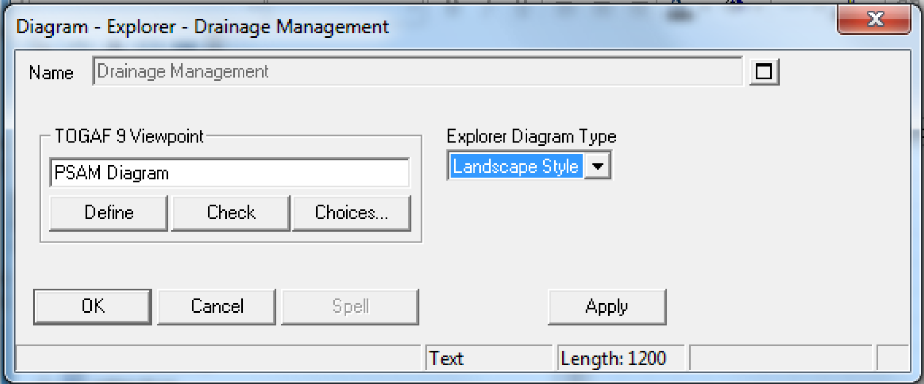

A PSAM Diagram is just an Explorer diagram that uses Landscape Style and is designated to have PSAM Diagram as the TOGAF 9 Viewpoint. You can create any viewpoints you want by creating a new TOGAF 9 Viewpoint definition.

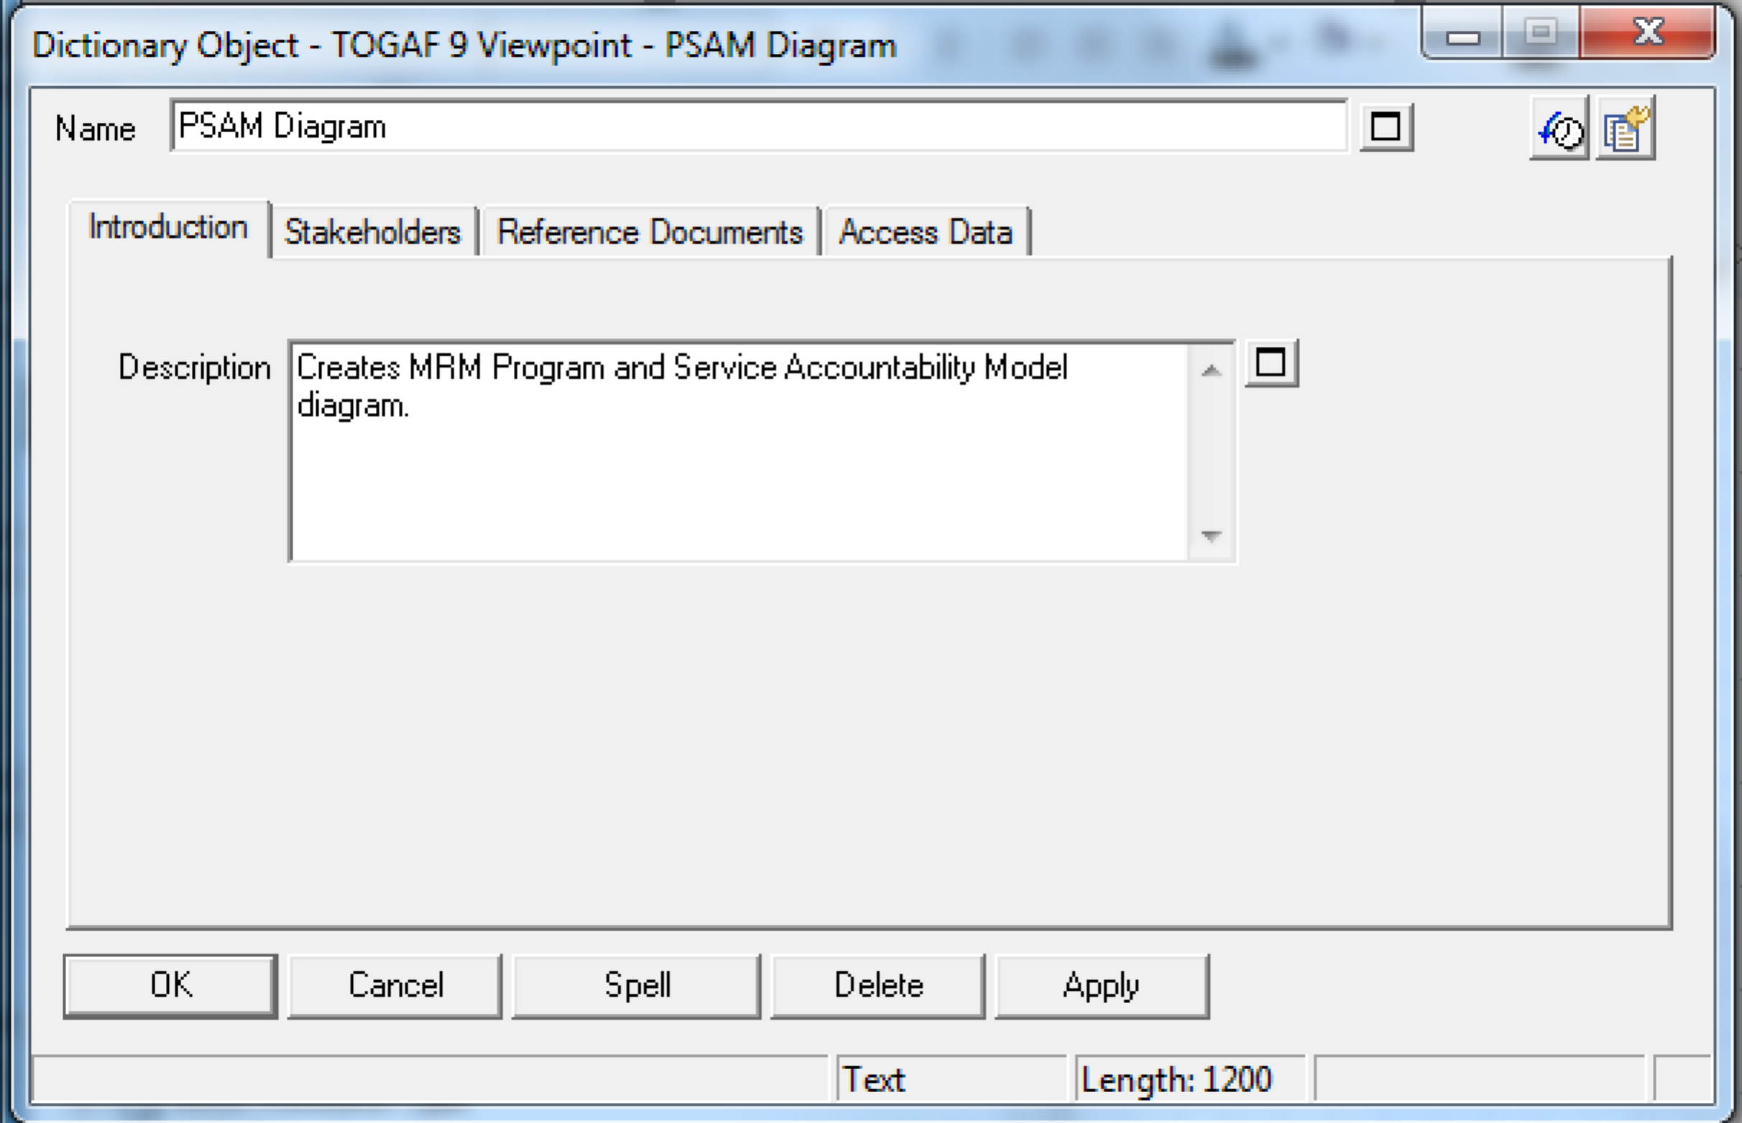

The TOGAF 9 Viewpoint can be used to customize the Heat Map Manager to indicate what analytics and explorer reports should be configured for that explorer diagram viewpoint. This will be covered below.

## Add Organization Units to the PSAM Diagram

Use any of the following means to add the desired MRM Organization Units to the PSAM Diagram you created above.

* Drag and drop the organization units from the Explorer view
* Drag and drop organization units from the References view
* Drag and drop organization units from a Grid report
* Drag and drop organization units that resulted from a Search
* Drag and drop an Explorer Object Report onto the diagram that finds organization units you are interested in, perhaps those that are categorized some particular way

When you drag and drop elements on an explorer diagram, they are automatically placed in a box labeled by the definition type. In many cases you may want to select this box and press the Delete key to remove the containing type box. You may also wish to edit the Display Mode for the organization units and deselect Graphic Comment so that the node type is not displayed on the diagram. Then click the Symbol Depictions toolbar button until the organization unit displayed as a simple rectangle, or a rectangle with an icon decorator, whichever you prefer.

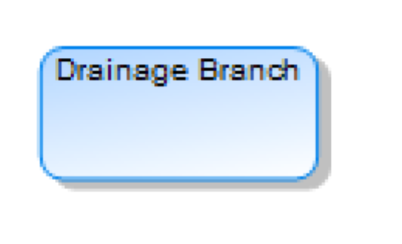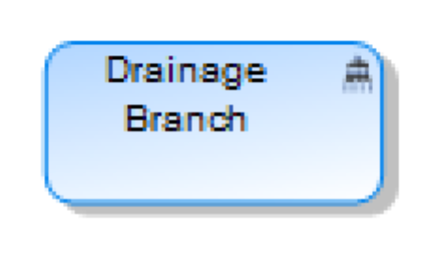

## Add the Administered Programs and Services and Delivered Outcomes

Open the Heat Map Manager View. With the PSAM Diagram as the current diagram, click on the MRM PSAM Explorer Complex Report in the Heat Map Manager view. The diagram is automatically populated with the programs, services and outcomes the organization units on the diagram are accountable for. You can also drag the MRM PSAM Explorer Complex Report from the Explorer view onto the Explorer diagram to get the same effect without having to open the Heat Map Manager view.

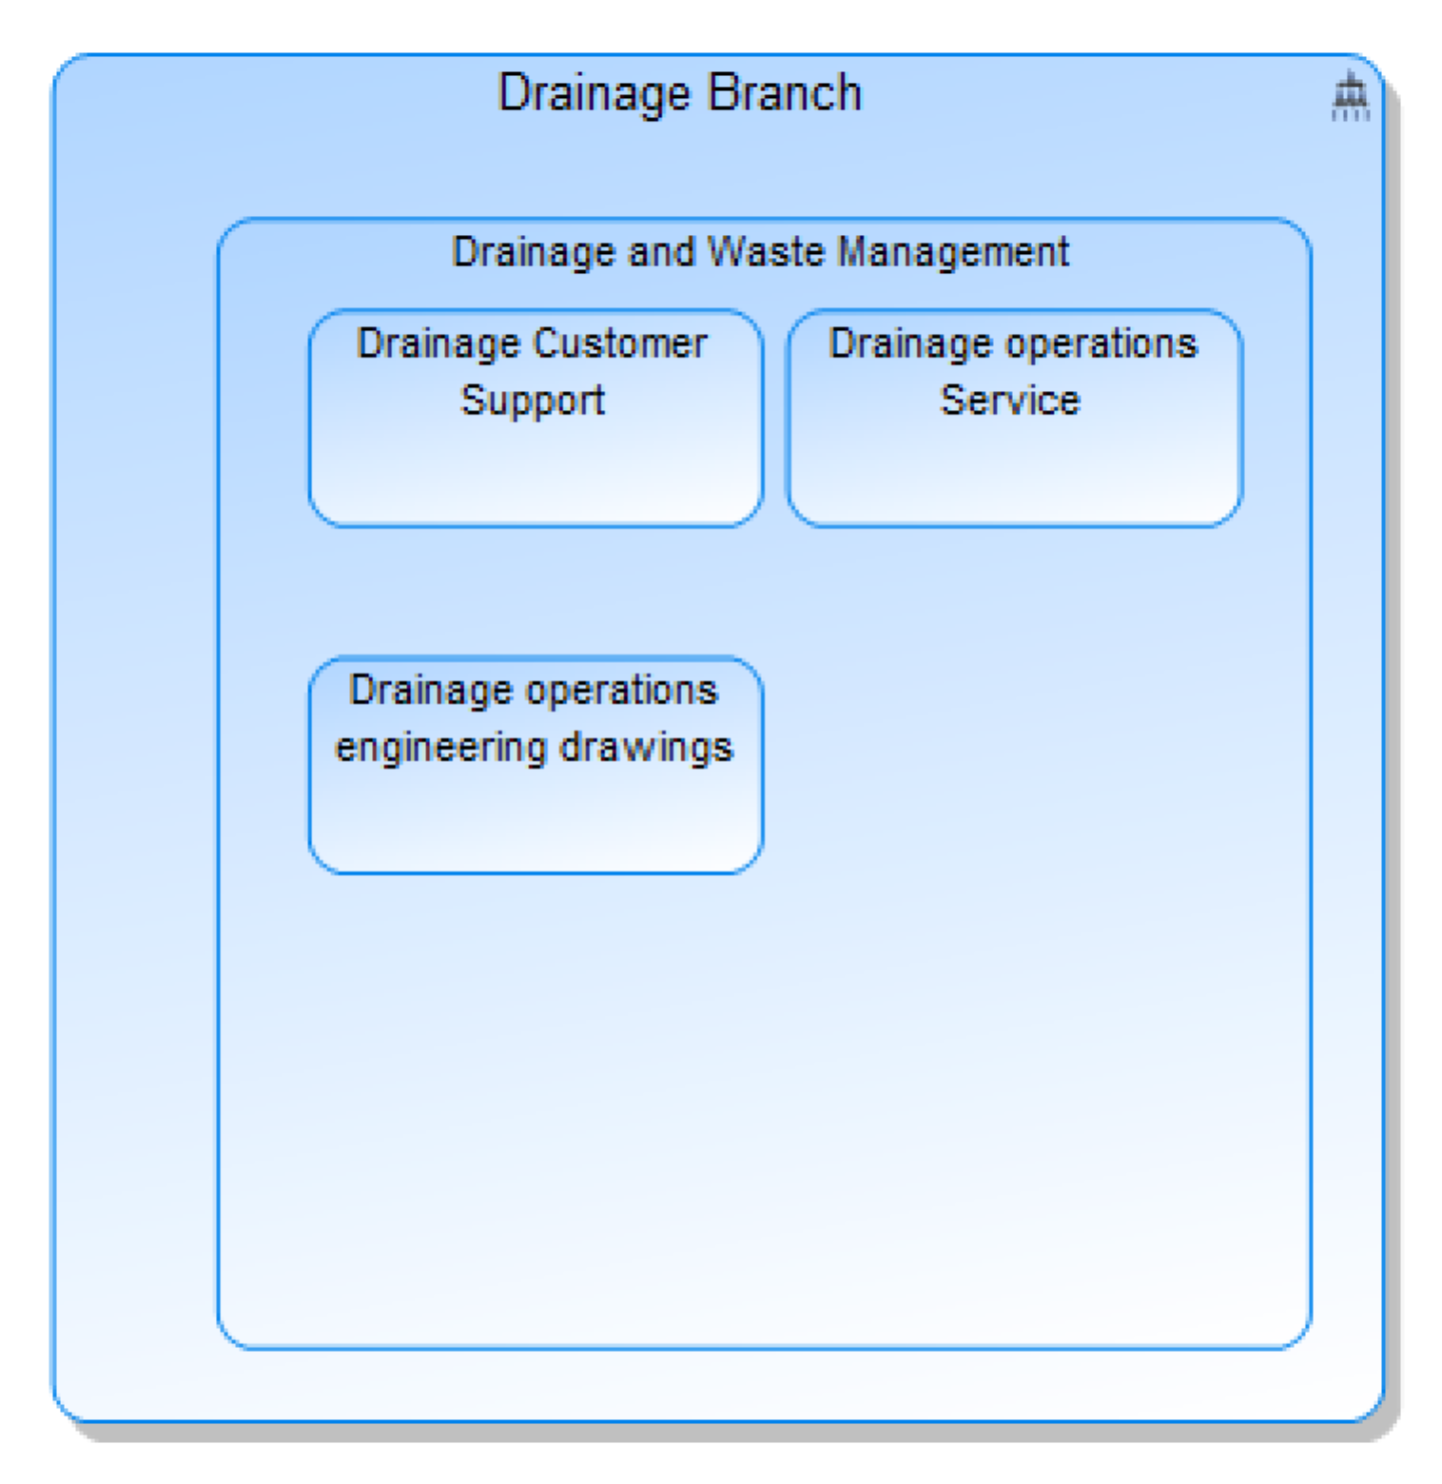

You can set the fonts and background colors for the programs and services as you wish to enhance the readability and visual appeal of the diagram. You can also edit the diagram properties and set any style properties needed to control the layout.

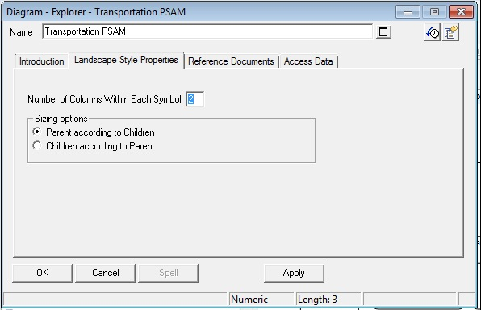

Explorer Relationship Reports have been created to navigate the relationships above, one for each layer that will be include in the diagram. These relationship reports can be used to create the parent/child elements in a landscape style explorer diagram. Note that there are two styles for explorer diagrams: network style and landscape style, set in the Explorer Diagram Type property when creating the diagram. The network style displays definitions and relationships as nodes connected by lines. The landscape style displays the relationships as nodes nested in other nodes. The PSAM diagram uses the landscape style.

There are three Explorer Relationship reports, each one adding elements to the diagram:

* MRM Organization Unit accountableFor Program
* MRM Program administers Services
* MRM Service contributesTo Outcome (this is a multi-step report to navigate from a service to its output, service value and outcome)

These included in the “MRM PSAM” Explorer Complex Report so they can all be executed in one step.